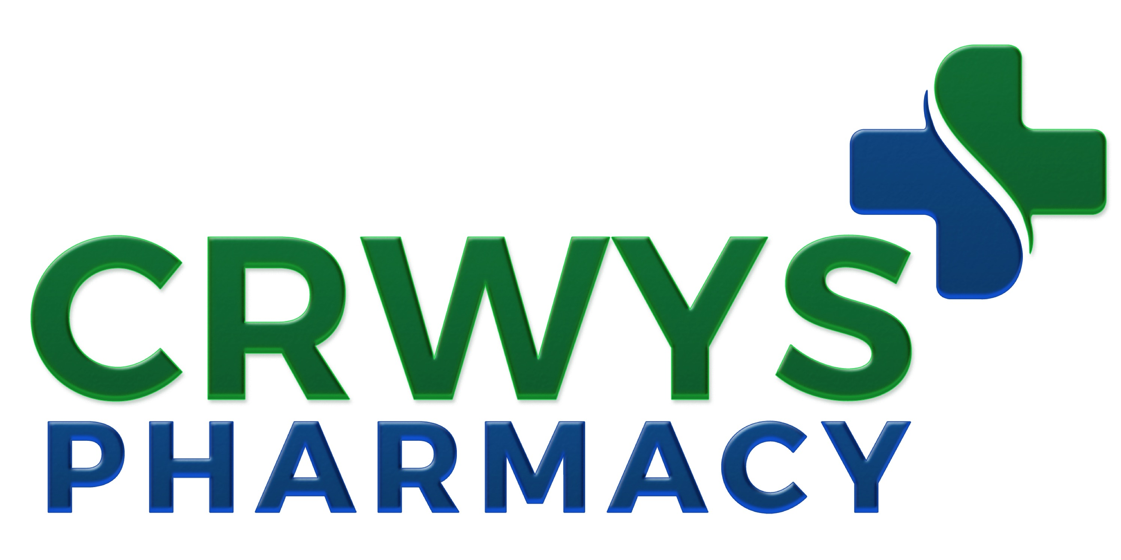

128 Crwys Road, Cathays, Cardiff, CF24 4NR

PRIVACY NOTICE

We process your personal data, which includes your name, contact details, prescription medicines and data from other pharmacy and health care services we provide to you (including, for example, pharmacy medicines, medicine use reviews, emergency supply services and discharge medication reviews) for the purposes of:

Your care – providing pharmacy services and care to you and, as appropriate, sharing your information with your GP and others in the wider NHS;

Our payments – sharing your information with the NHS Business Services Authority, others in the wider NHS, and sometimes Local Authorities, and only limited information to those external to the NHS who negotiate and check the accuracy of our payments; and,

Management – sharing only limited information with the NHS Business Services Authority and others in the wider NHS, and sometimes Local Authorities; as well as those external to the NHS who ensure we maintain appropriate professional and service standards and that your declarations and ours are accurate.

We hold your information for as long as advised by the NHS. You have a right to a copy of the information we hold about you, generally without charge. You may seek to correct any inaccurate information.

We process your personal data in the performance of a task in the public interest, for the provision of healthcare and treatment and the management of healthcare systems. A pharmacist is responsible for the confidentiality of your information. You may object to us holding your information. You may also lodge a complaint with the Information Commissioner's Office, Wycliffe House, Water Lane, Wilmslow, Cheshire SK9 5AF. Please ask if you want more information.

Our Data Protection Officer is Mr Mark Roberts of MR Associates UK.

